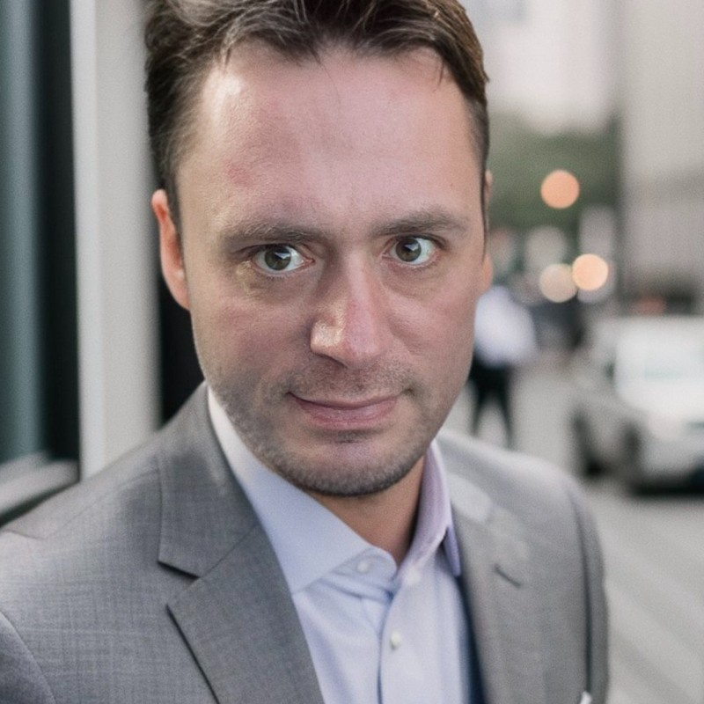

Gilles Fauvie

**Linux sysadmin - Open Source Databases Administrator**

## 

## **PERSONALIA**

* Full name : Gilles Constant Jean-Henri Fauvie
* Phone : +32 487 18 16 51 / Email : gilles@dbfactory.io
* Nationality : Belgian
* Born : July 2nd 1979

## **EDUCATION**

* DALIBO, Paris, France – Postgresql Database Administrator – 2012-2013 ;
* Solvay Business School, Brussels, Belgium - Entrepreneurship Program, 2010-2012 ;
* BULL/EVIDIAN, Brussels, Belgium, - Web Access Manager & Safekit, 2010 ;
* TIPTEL, Zaventem, Belgium, - VoIP, 2010 ;
* ULB, Brussels, Belgium, - Quality Manager ISO9000, 2002 ;
* HECE, Hainaut, Belgium, - Bachelor in Computing Technology, 2001 ;
* I.N.D, Hainaut, Belgium, - High school diploma in Sciences/Mathematics, 1998 ;

## **RELATED EXPERIENCE**

* DBA/Linux Sysadmin at EUROCLEAR S.A, Bruxelles, Belgium, 2023/09 – 2025/02
  + PostgreSQL optimization / Backup / HA / Disaster Recovery / Load Balancing
  + Ansible automation for PostgreSQL deployment
  + Training sessions and documentation
  + Management servers (pgadmin, pgbadger, POWA)
* DBA/Linux Sysadmin at TUC RAIL, Bruxelles, Belgium, 2022/10 – 2023/06
  + PostgreSQL optimization / Backup / HA / Disaster Recovery
  + Linux RHEL administrator
* DBA at NETHIS, Charleroi, Belgium, 2022/06 – 2022/09
  + PostgreSQL optimization / Backup / HA / Disaster Recovery
* DBA at IPEX, Tubize, Belgium, 2021/10 – 2022/09
  + Linux System Engineer (Debian)
  + MySQL setup / Backup / Disaster Recovery
  + ElasticSearch DBA
* DBA at Interieur Binnenland Zaken (IBZ – Direction Générale Institution et Population), Brussels, Belgium, 2005/09 – 2020/11 – Contact : Mr Eric Roelandt, email : eric.roelandt@rrn.fgov.be) – <http://www.ibz.be>
  + Linux System Engineer (RHEL/UBUNTU/DEBIAN) ;
  + PostgreSQL Monitoring / Disaster recovery / Set up “homemade” software for full backup and Point In Time Recovery (PITR) to use NetBackup (not compatible with Barman or Pitrery);
  + Set up all the PostgreSQL dev environment to migrate from GCOS mainframe to LiberTP (product developed by Atos Phoenix based on JBOSS to replace mainframe);
  + Set up monitoring system: Munin and Nagios Enterprise Edition;
  + Set up a script for daily report to identify worst SQL request and find a way to fix it;
  + Set up a “degraded mode”: 2 PostgreSQL servers linked by FDW. Goal: to get the production up as soon as possible in case of disaster. PostgreSQL server 1: only text data (80% of production is up in this case), PostgreSQL server 2: binary data (photos, signatures of eId cards), (100% of production is up in this case);
  + Developing functions (PL/PGSQL and PL/Python) to verify data consistency and to be compatible with the mainframe GCOS;
  + Set up PostgreSQL partioning;
  + Set up high availability using Virtual Ip Address and SAN (2 sites);
  + Assistance to the developers for SQL queries;
  + Creating Munin probe dedicated for PostgreSQL (<https://raw.githubusercontent.com/munin-monitoring/contrib/master/plugins/postgresql/postgres_tuplesratio_>);
  + Managing all the PostgreSQL environments (dev, preprod, testing for final users, prod);
  + Assistance for architecture and design of the PostgreSQL database;
  + Migrating production data from a main version of PostgreSQL to a new one;
  + Set up a frontend LDAP with backend PostgreSQL;
  + Set up a Foreign Data Wrapper PostgreSQL <-> MongoDB;
  + Set up slony replication, Wal replication, streaming replication and logical replication;
  + Set up a script bash to get the last transaction in security even in case of crash disk;
  + MongoDB cluster with high availability to save log messages (Syslog) and setup a bootstrap interface to have a way to get information “user-friendly”;
  + Optimizing OS, memories, filesystems;
  + Set up pooler (PG-POOL and PgBouncer);
  + Providing training sessions;
  + Link PostgreSQL to Web Access Manager (for eId authentication);
  + Set up triggers for data consistenty;
* Mondial Relay, Paris, France, 2018/01 – 2019/08 – Contact: Pierre Yves ROUZAUD, pyrouzaud@mondialrelay.fr –<http://www.mondialrelay.fr>
  + Set up high-availability (logical replication);
  + Set up backup (Barman and pg_receivexlog);
  + Disaster recovery;
  + PL/PGSQL;
  + Datawarehouse;
  + Set up triggers for data consistenty;
* Ordre des barreaux francophones de Belgique, Brussels, Belgium, 2018 – Contact : Mr Philippe Dhondt, ph.informatique@avocats.be – <http://www.avocats.be>
  + Set up a high availability cluster;
  + Migration of 9 databases (from Oracle, MsSql) to one PostgreSQL cluster;

More projects available on demand: EVEA GROUP FRANCE, City of Charleroi, AGC EUROPE, British Telecom, ARSIA/AFSCA, …

## **SKILLS**

* General :
  + Ability to quickly learn and understand from self-study or analysis;
  + Good understanding of project management and change management;
  + Team player – listen, share, cooperate and learn together as a team;
  + IT knowledge : Linux (RHEL, Ubuntu, Gentoo, Fedora, Tails, ...), Open Source Integration, Python, TCP/IP, DNS, DHCP, Apache, Iptables, Nagios, Zabbix, Munin, Bash, FTP, Syslog, OpenVPN, TCPDUMP, NMAP, CARP, SamWEB (Evidian), Safekit (Evidian), PHP, C, KVM, ESX, PEN, X.509 Certificate, NTP, OpenLDAP, Network, Java J2EE.
  + PostgreSQL: High availability, backup, monitoring, audit (PgBadger, …), pgpool, pgbouncer, pgbadger, POWA, pg_receivexlog, system tables, replication, monitoring, functions (PL/PGSQL, PL/Python), optimization, partitioning, triggers, alive/dead tuples, ACID, views, ;
  + MongoDB: clustering, sharding, backup, disaster recovery;

## **LANGUAGES**

* French : native
* English : gook working knowledge spoken and written
* Dutch : basic knowledge spoken and written